Week 12-14 : Deployment and Publishing Mobile Applications.

Learning Outcomes
Sales Management Application
1. Brief Description of the Application (2 Marks)
The Sales Management Application is an Android-based system developed to help businesses efficiently manage their sales operations. The application enables users to record sales transactions, manage customer information, monitor product inventory, and generate sales reports. It provides a simple and user-friendly interface that improves accuracy, reduces manual paperwork, and supports better decision-making through organized sales data.
Main Objectives:
- Record and manage sales transactions.
- Store customer information.
- Manage product inventory.
- View sales history and reports.
- Improve business efficiency and reduce manual record keeping.

2. Screenshots of the Application's Key Features (3 Marks)
Insert screenshots of the following pages in your report.
Screenshot 1: Login Screen
Description:
Allows authorized users to log into the application using their username and password.
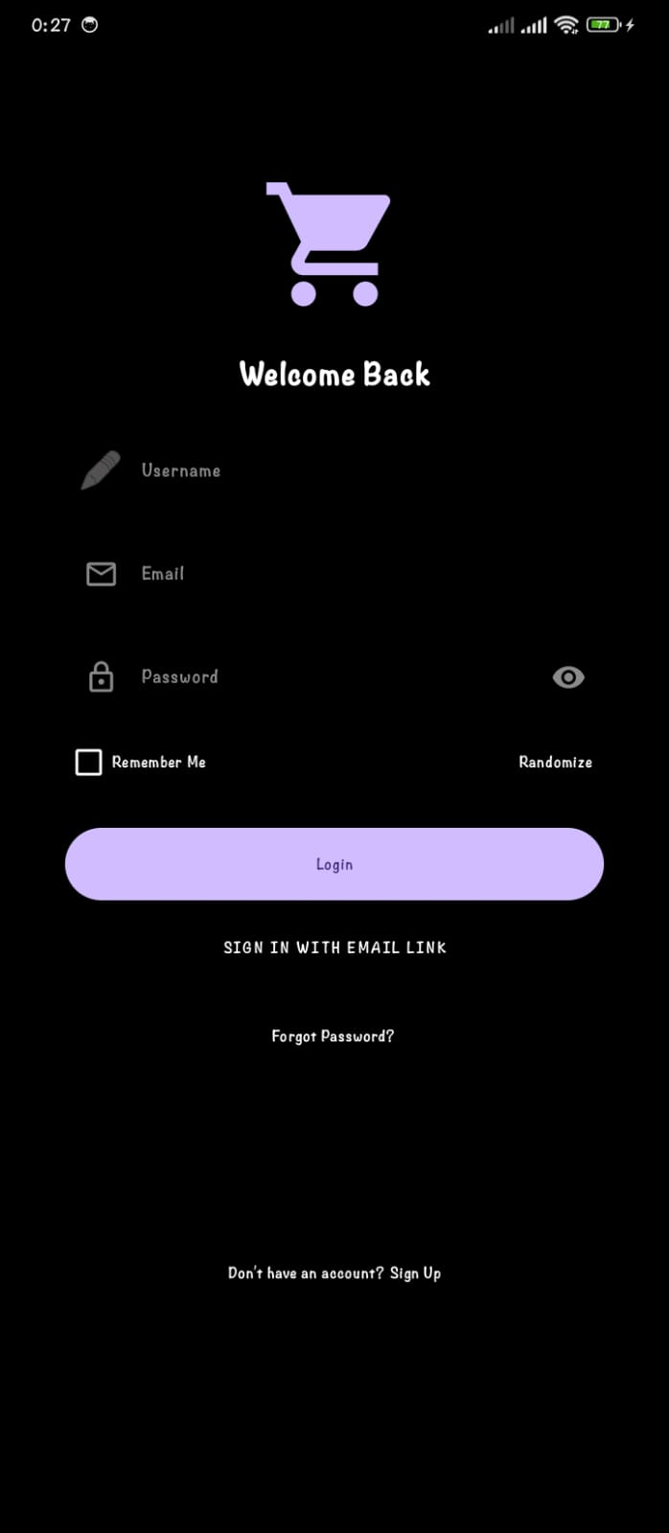

Screenshot 2: Dashboard/Home Screen
Description:
Displays the main menu where users can access Products, Customers, Sales, Reports, and Settings.
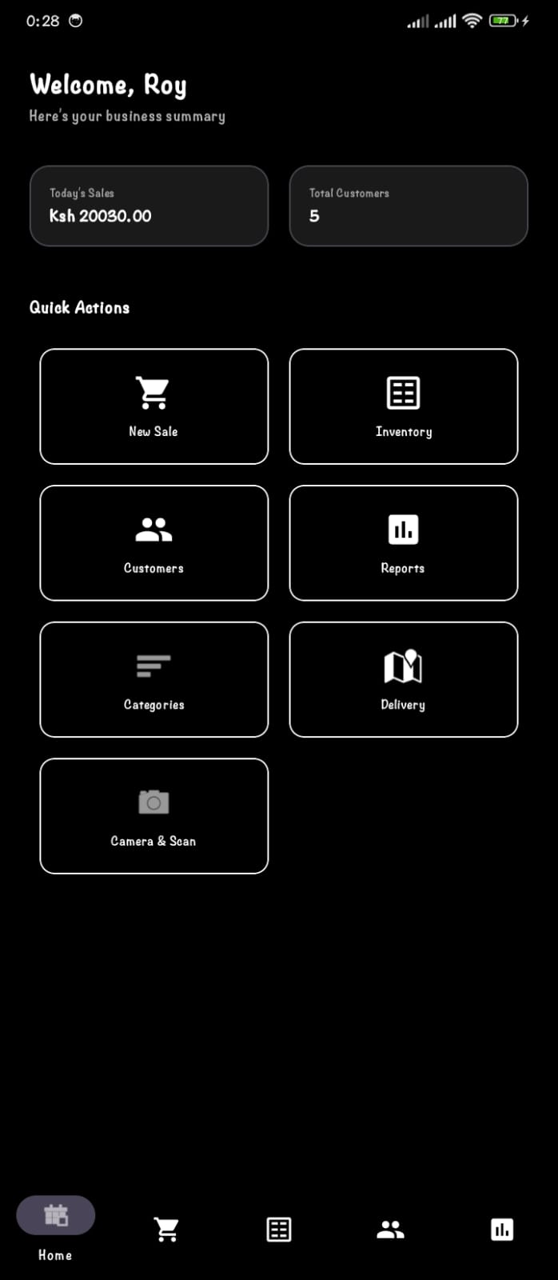

Screenshot 3: Product Management
Description:
Allows users to add, edit, delete, and view products together with their prices and available stock.
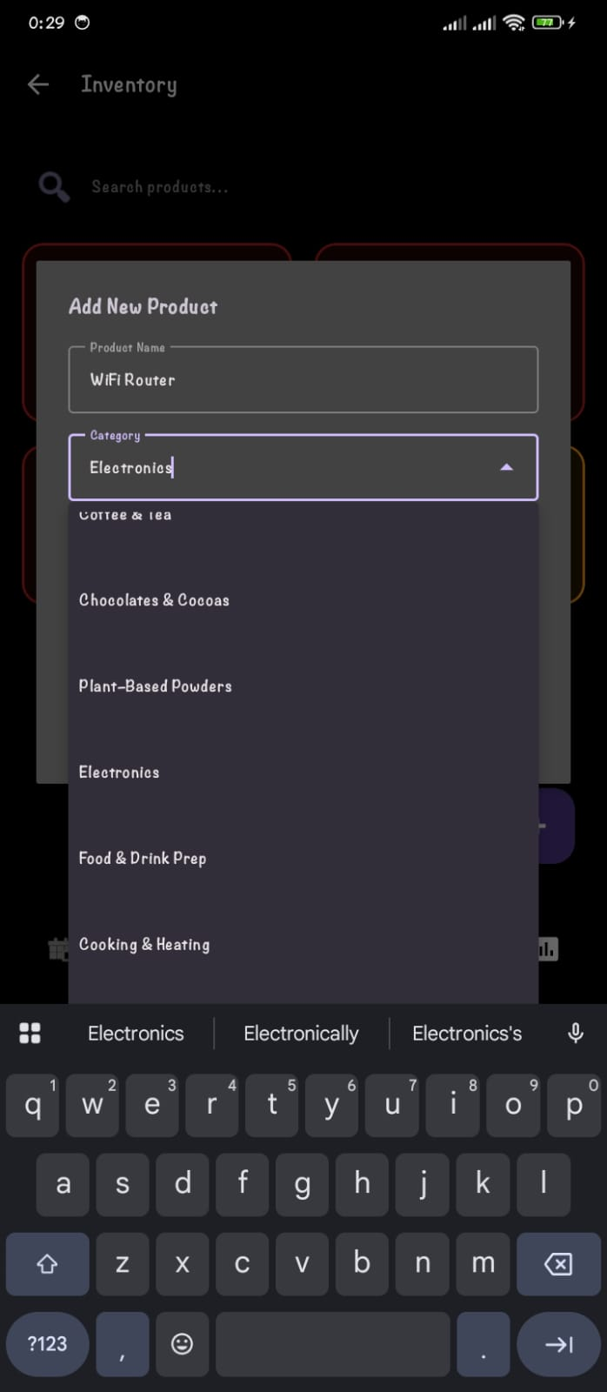

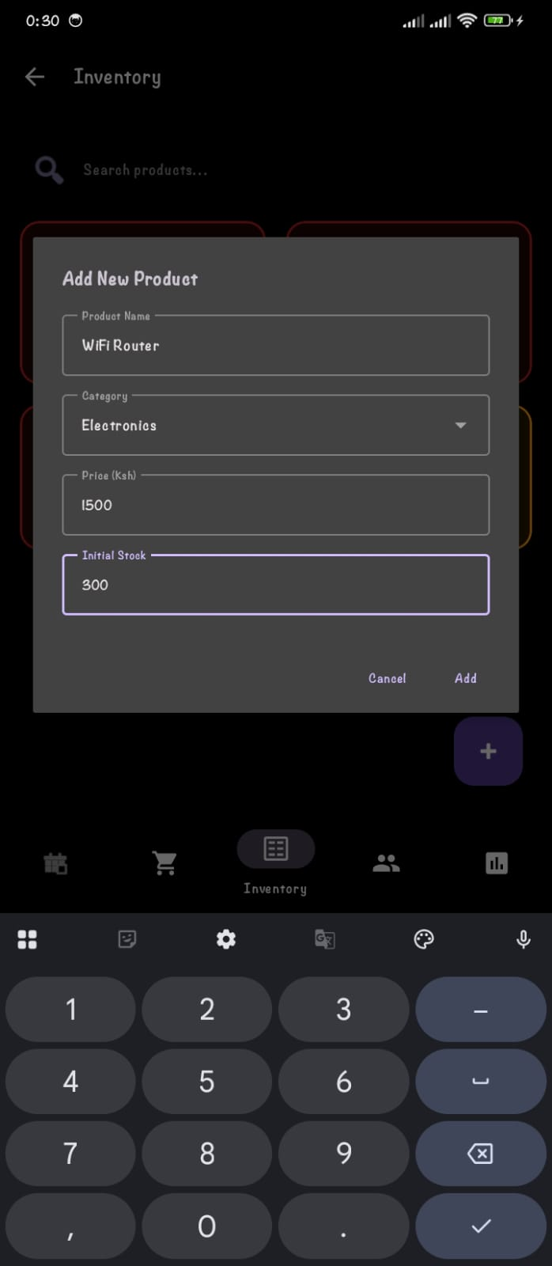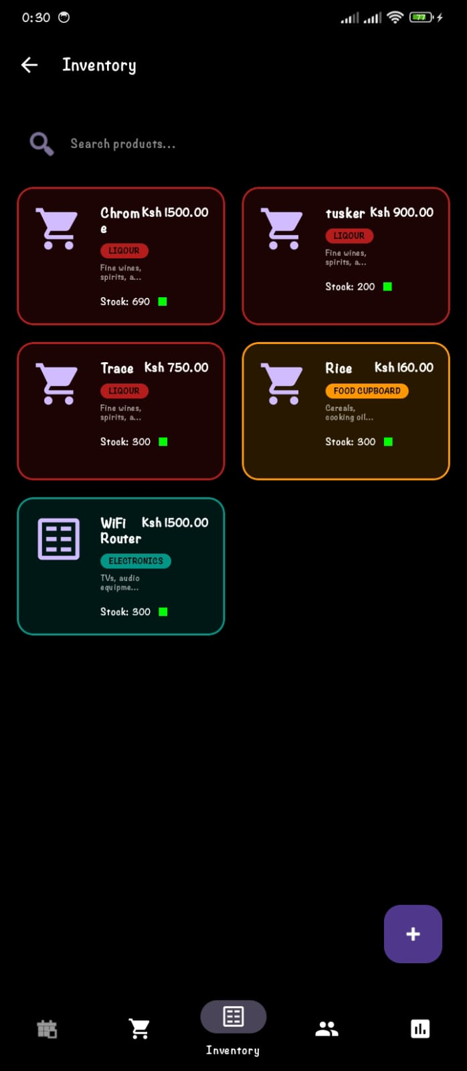

Screenshot 4: Customer Management
Description:
Enables users to register new customers, edit customer information, and search customer records.
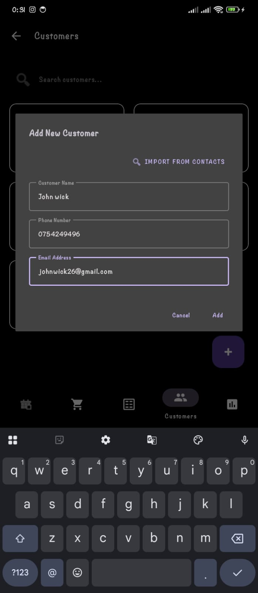
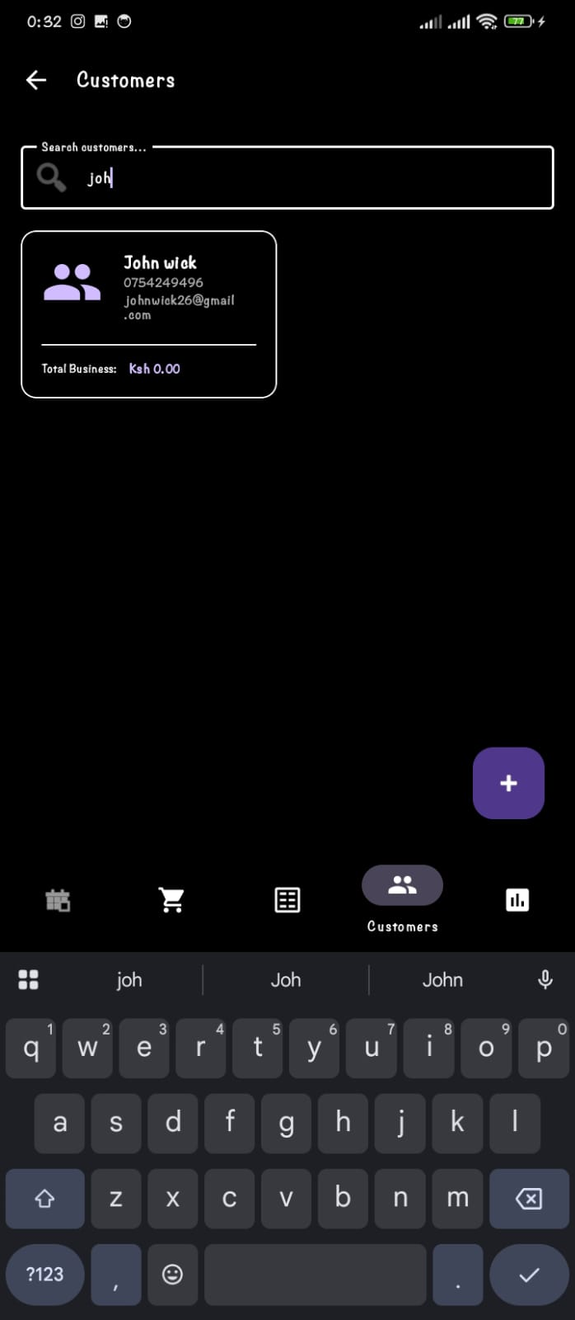

Screenshot 5: Sales Transaction Screen
Description:
Allows users to record new sales by selecting products, entering quantities, calculating totals, and saving transactions.
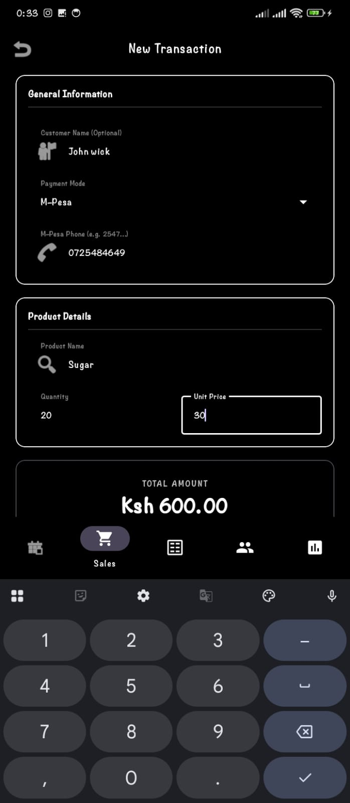
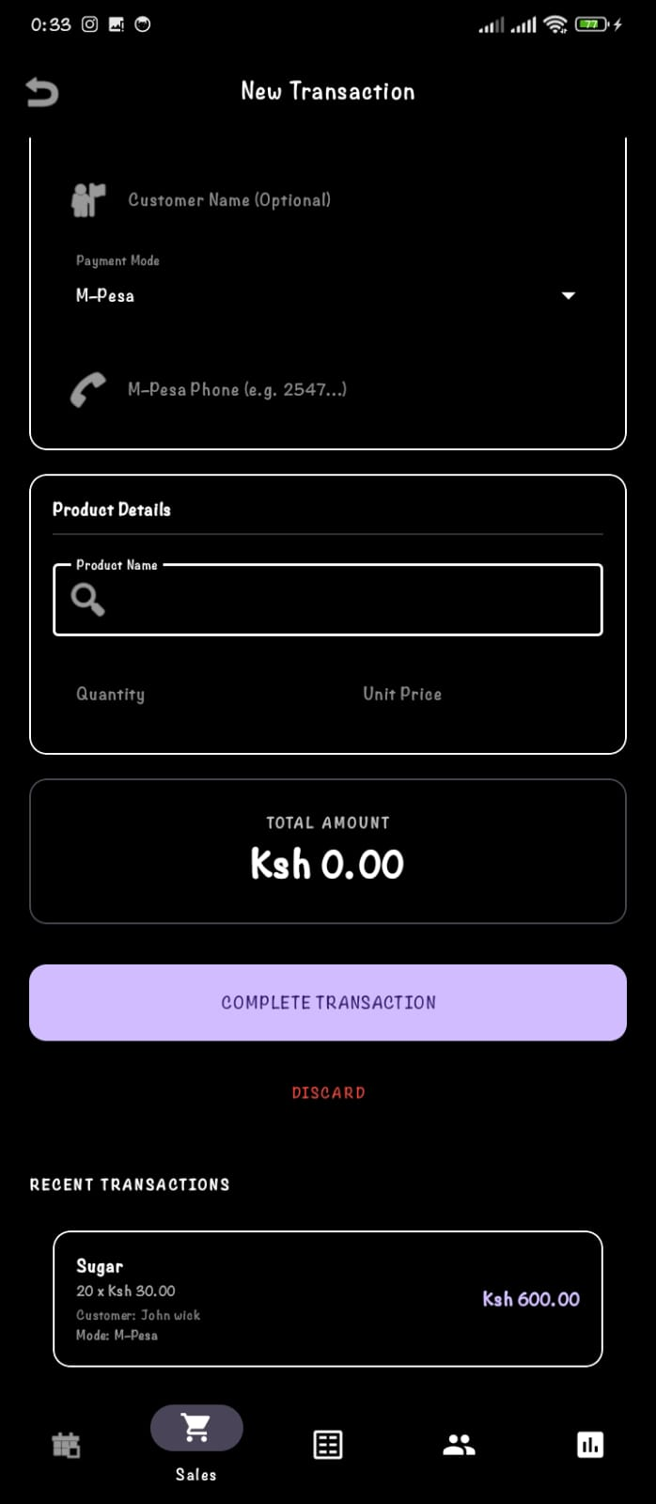

Screenshot 6: Sales Report Screen
Description:
Displays sales summaries, transaction history, and total revenue generated over a selected period.
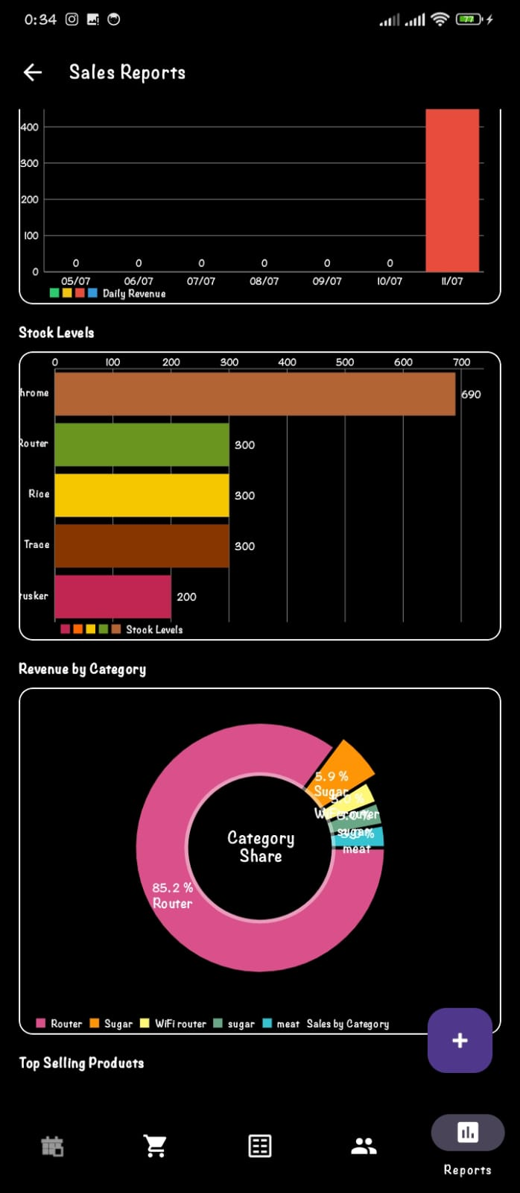

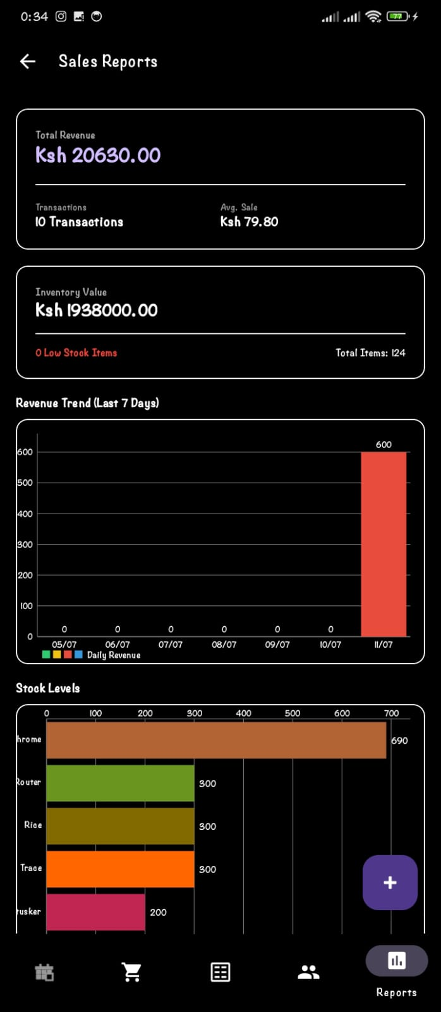

3. Application Version Name and Version Code (2 Marks)
Item | Value
Application Name | Sales Management Application
Version Name | Version 1.0
Version Code | 1
Package Name | com.salesmanagement.app
Platform | Android
Programming Language | Kotlin
Database | Firestore

4. Steps Followed to Generate a Signed Release Build
A signed release build was generated to prepare the Sales Management application for distribution and installation on Android devices. The following steps were followed:
- Open the Project
  - Open the Sales Management project in Android Studio and ensure that there are no compilation errors.
- Generate Signed Bundle/APK
  - From the Android Studio menu, select Build → Generate Signed Bundle / APK.
- Choose APK
  - Select APK as the build type and click Next.
- Create a Keystore
  - Click Create New to create a new keystore.
  - Specify the keystore location.
  - Enter a strong password.
  - Provide a key alias, key password, validity period, and certificate information (name, organization, city, country, etc.).
  - Save the keystore.
- Select the Keystore
  - Browse to the newly created keystore.
  - Enter the keystore password and key password.
  - Select the appropriate key alias.
  - Click Next.
- Configure the Release Build
  - Choose the release build variant.
  - Select the desired signature versions (V1 and V2).
  - Click Finish to start the build process.
- Build Completion
  - Android Studio compiles the application and generates the signed APK.
  - After the build completes successfully, a notification appears with the option to locate the generated APK.
- Locate the Signed APK
  - The signed APK is found in the project directory:
  - app → release → app-release.apk
  - This APK is ready for installation, testing, or distribution.
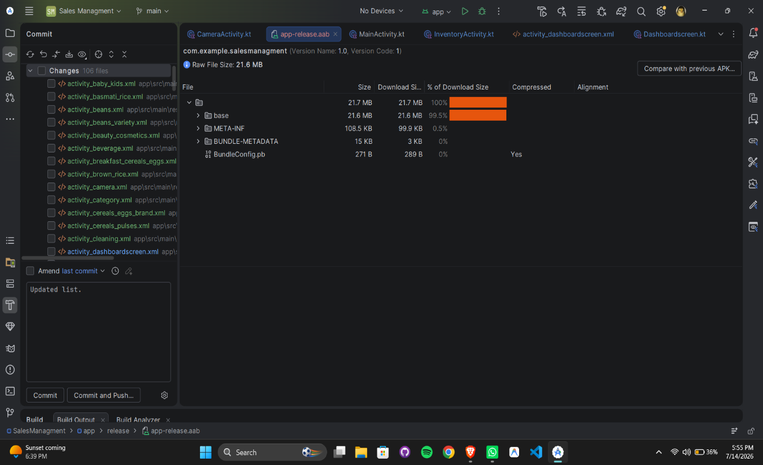

5. Draft Google Play Store Listing (5 Marks)
App Name
Sales Management System

Short Description
Manage products, sales, customers, and reports from one easy-to-use app.
Long Description
Sales Management System
The Sales Management System is an Android application designed to help businesses efficiently manage their daily sales activities. It provides a simple and user-friendly interface for recording sales, managing products, tracking customers, and monitoring business performance.
The application reduces manual record keeping and enables business owners and sales personnel to access sales information quickly and accurately.
Key Features
- User login authentication
- Product management
- Customer management
- Record sales transactions
- View sales history
- Sales reports
- Dashboard displaying business statistics
- Easy navigation and modern interface
Benefits
- Improves sales tracking
- Reduces paperwork
- Saves time
- Minimizes calculation errors
- Provides quick access to sales information
- Supports better business decision making
Target Users
- Small businesses
- Retail shops
- Wholesale businesses
- Sales representatives
- Business managers
Requirements
- Android 8.0 (API Level 26) or higher
- Internet connection (if connected to an online database)

Screenshots










App Icon
📱 Sales Management App Icon
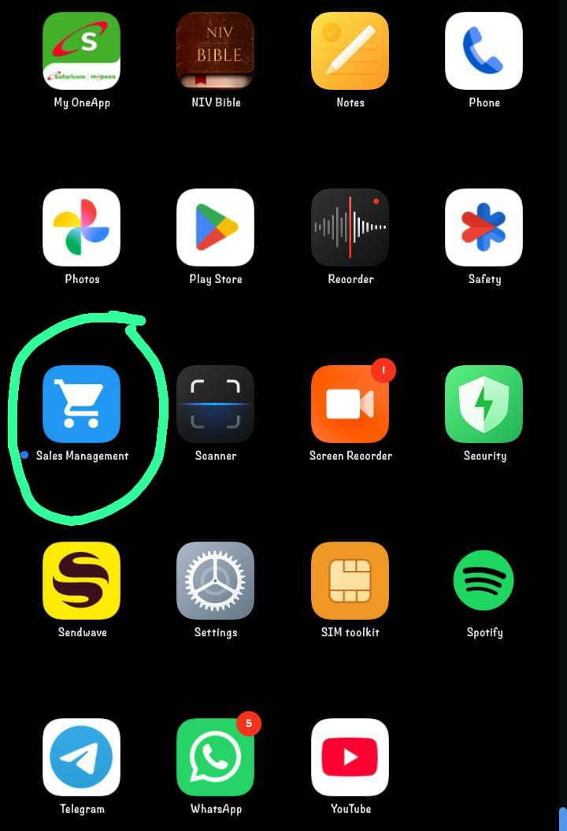

2. Challenges Encountered During Deployment and Proposed Solutions (4 Marks)
Challenge | Proposed Solution
Application failed to build due to Gradle errors | Updated Gradle version and synchronized project files.
Release APK could not be generated because no keystore existed | Created a new keystore and generated a signed release build.
Application crashed after installation due to missing permissions | Declared all required permissions in AndroidManifest.xml.
Version code conflict during release | Increased the version code and updated the version name before generating the release build.

Testing and Debugging
1. Application Overview (2 Marks)
Purpose of the Application
The Sales Management App is an Android application developed to help small businesses and sales personnel efficiently manage sales activities. The application enables users to record products, manage customer information, track sales transactions, and monitor business performance in a simple and organized manner. Its goal is to replace manual record-keeping with a faster, more accurate digital solution.
Main Features
- User Authentication – Secure login and registration for authorized users.
- Product Management – Add, edit, delete, and view products with details such as name, price, and quantity.
- Customer Management – Store and manage customer information, including names and contact details.
- Sales Recording – Record new sales transactions by selecting products, entering quantities, and calculating the total amount.
- Sales History – View a list of previous sales transactions for tracking and reference.
- Dashboard – Display key business information such as total products, customers, and sales.
- Search Functionality – Quickly search for products or customers.
- Data Validation – Prevent incomplete or incorrect data from being saved, improving data accuracy.

2. Unit Testing
1. SalesCalculator.kt
class SalesCalculator {

fun calculateTotal(price: Double, quantity: Int): Double {
return price * quantity
}
}
SalesCalculatorTest.kt
import org.junit.Assert.assertEquals
import org.junit.Test

class SalesCalculatorTest {

@Test
fun calculateTotal_returnsCorrectTotal() {
val calculator = SalesCalculator()

val result = calculator.calculateTotal(100.0, 5)

assertEquals(500.0, result, 0.01)
}
}

3. Debugging Process
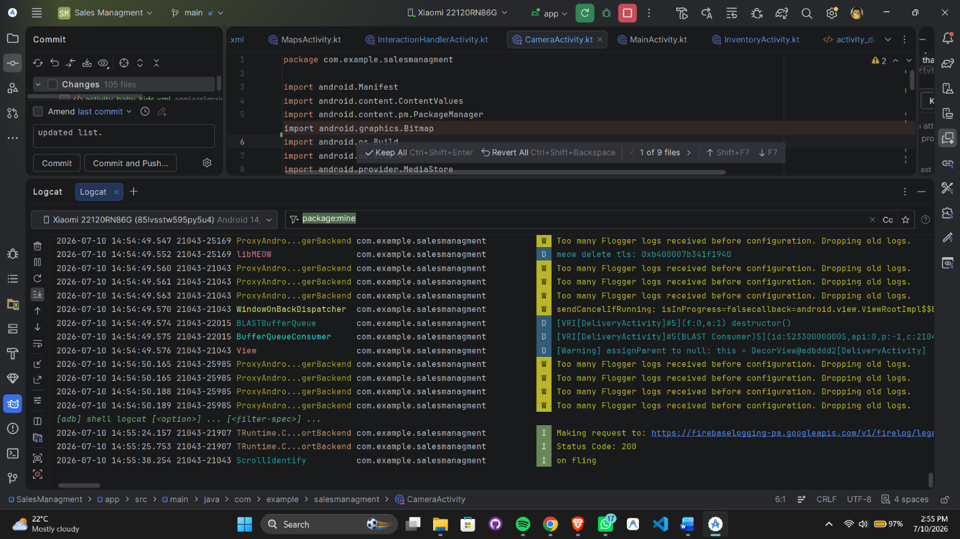

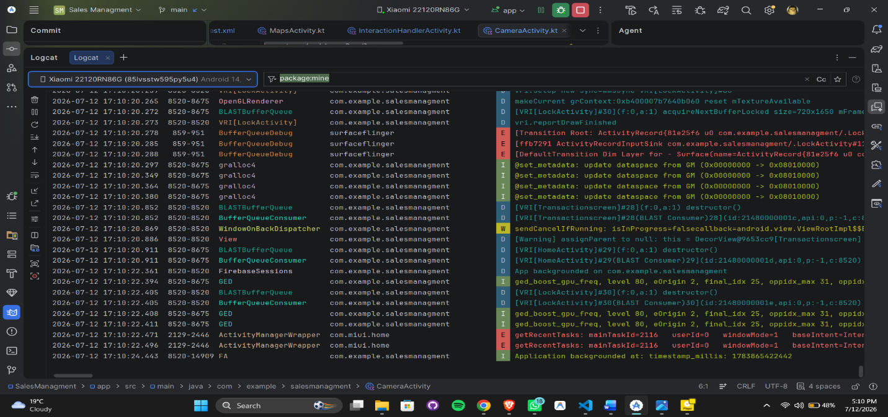
Test Results
The Transaction activity is responsive and accessible to navigate through.It shows the stability of each and every data input including the items and customers ID.
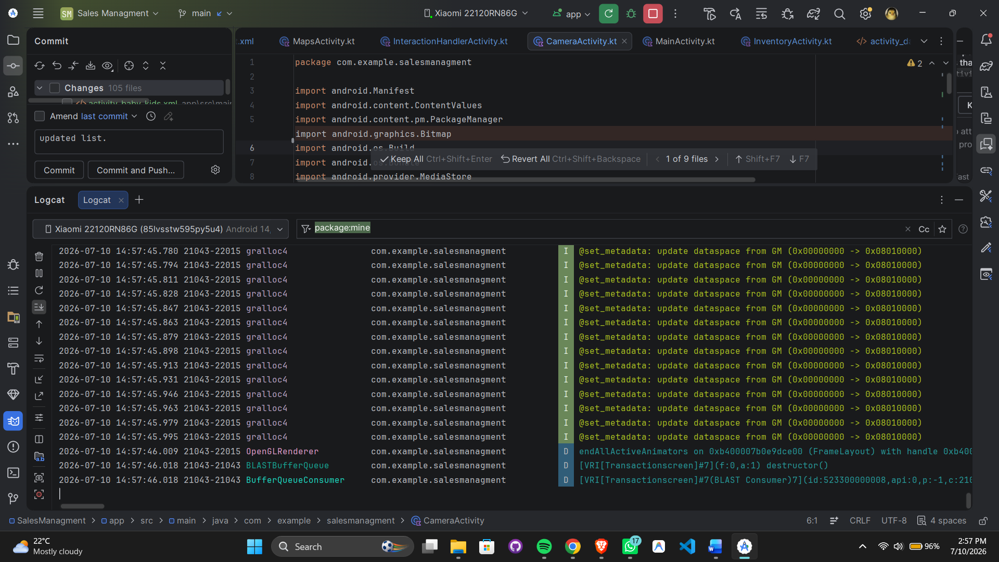

Personal Reflection
Importance of Testing
Testing was a critical part of developing the Sales Management App because it ensured that the application's features worked correctly and reliably. By creating and running JUnit tests, I was able to verify that core functions such as adding products, updating sales records, deleting records, and calculating totals produced the expected results. Testing also helped identify errors early in the development process, reducing the chances of bugs appearing in the final application. Overall, testing improved the application's quality, stability, and user experience.
Importance of Debugging
Debugging played an important role in identifying and fixing issues that occurred during development. Android Studio tools such as Logcat, breakpoints, and variable inspection made it easier to locate the source of errors. For example, when a NullPointerException occurred due to an uninitialized object, Logcat displayed the error message and stack trace, while breakpoints allowed me to inspect variable values step by step. Debugging helped ensure that the application ran smoothly and reduced unexpected crashes.

Lessons Learned
Developing the Sales Management App provided valuable practical experience in Android application development. Through the project, I learned how to:
- Design and implement CRUD (Create, Read, Update, Delete) operations using Kotlin.
- Connect an Android application to a local database for storing and retrieving sales information.
- Write and execute JUnit tests to verify application functionality.
- Use Android Studio debugging tools such as Logcat, breakpoints, and variable inspection to diagnose and fix errors.
- Generate a signed release build (APK/AAB) for deployment.
- Appreciate the importance of testing and debugging in producing reliable, maintainable, and user-friendly software.

